**UNIVERSIDAD DE LAS FUERZAS ARMADAS “ESPE”**

**Name:** Fernanda Galárraga

**CREATE A REPOSITORY IN GITLAB**

1. Go to the official GitLab page.



1. Then go to the registration tab and place the necessary data for the registration, such as the name, user, email to which our GitLab account will be associated and the password.

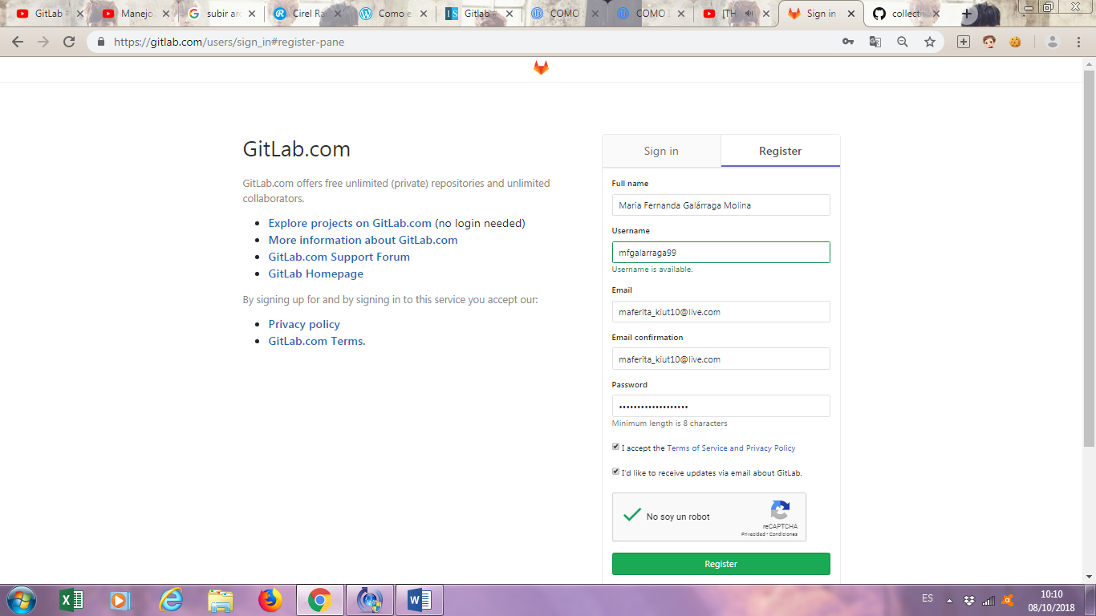

1. Accept the terms and conditions, then click on "Register".



1. A window will appear indicating the user to verify the account through the email that was associated.



1. Access the email associated with the GitLab account to verify the account. Click on "Confirm your account".

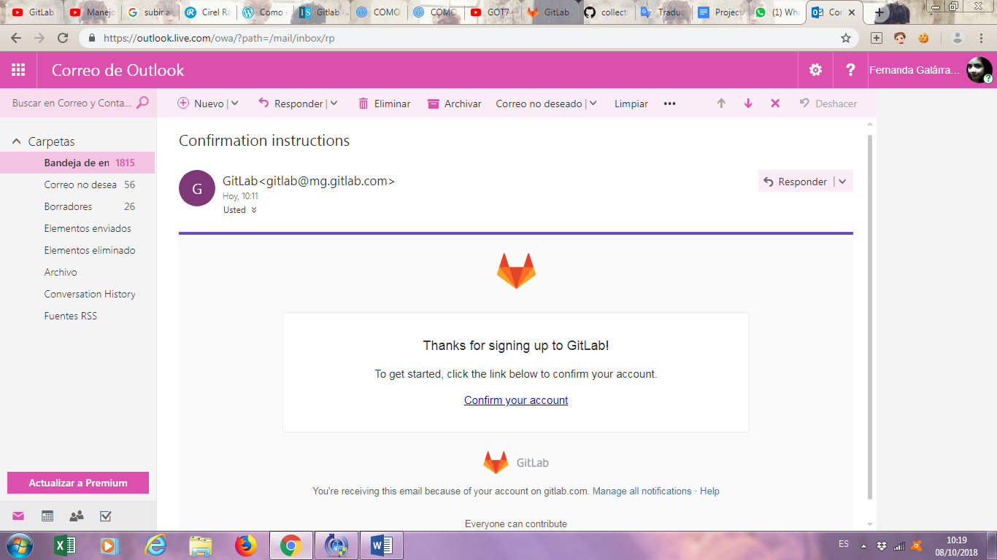

1. After checking, we must access our GitLab account.

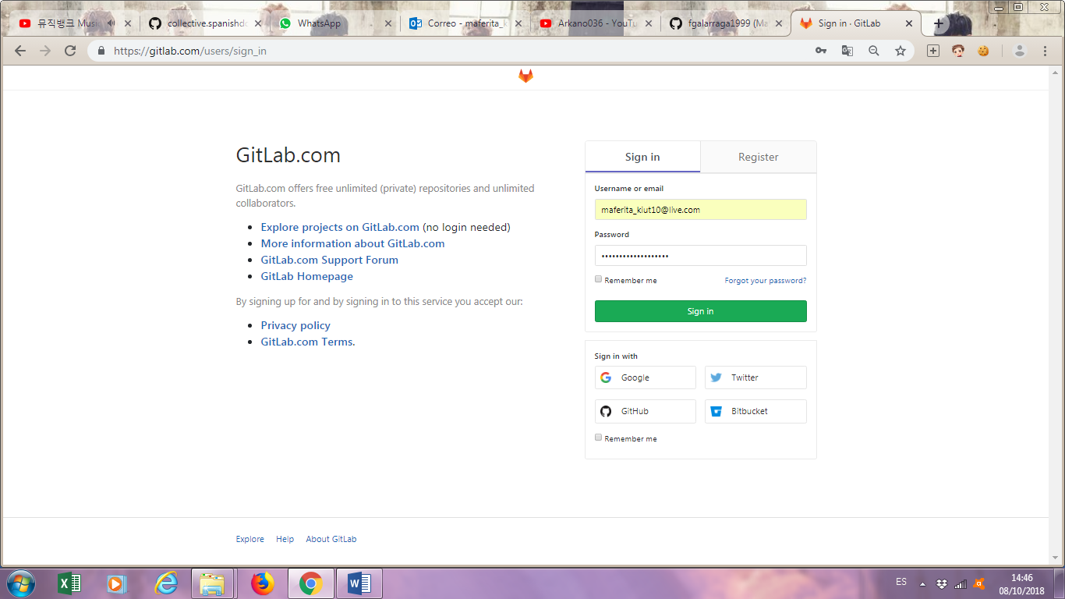

1. Click on "Create a Project" to create a new repository.

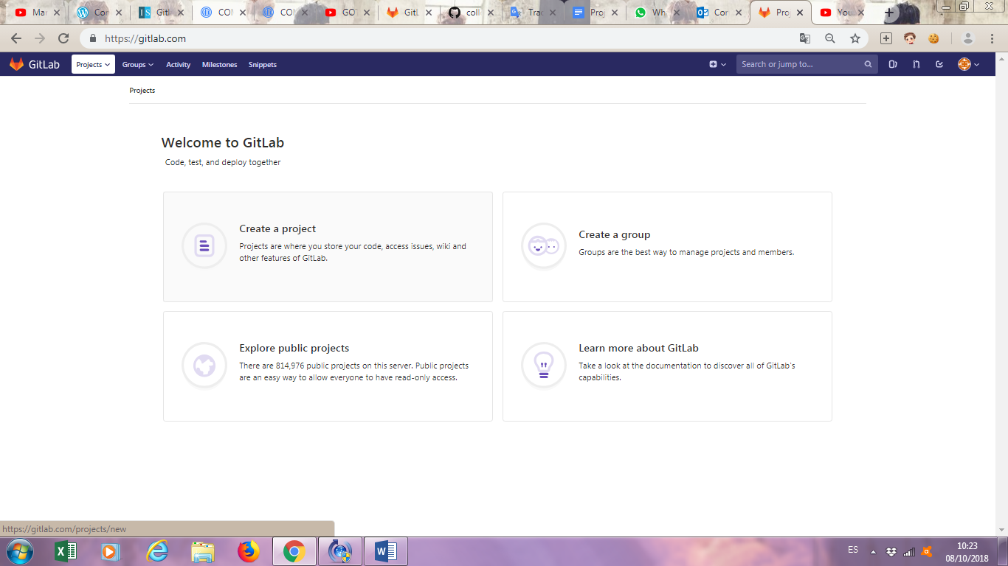

1. Enter the name and description of the project.

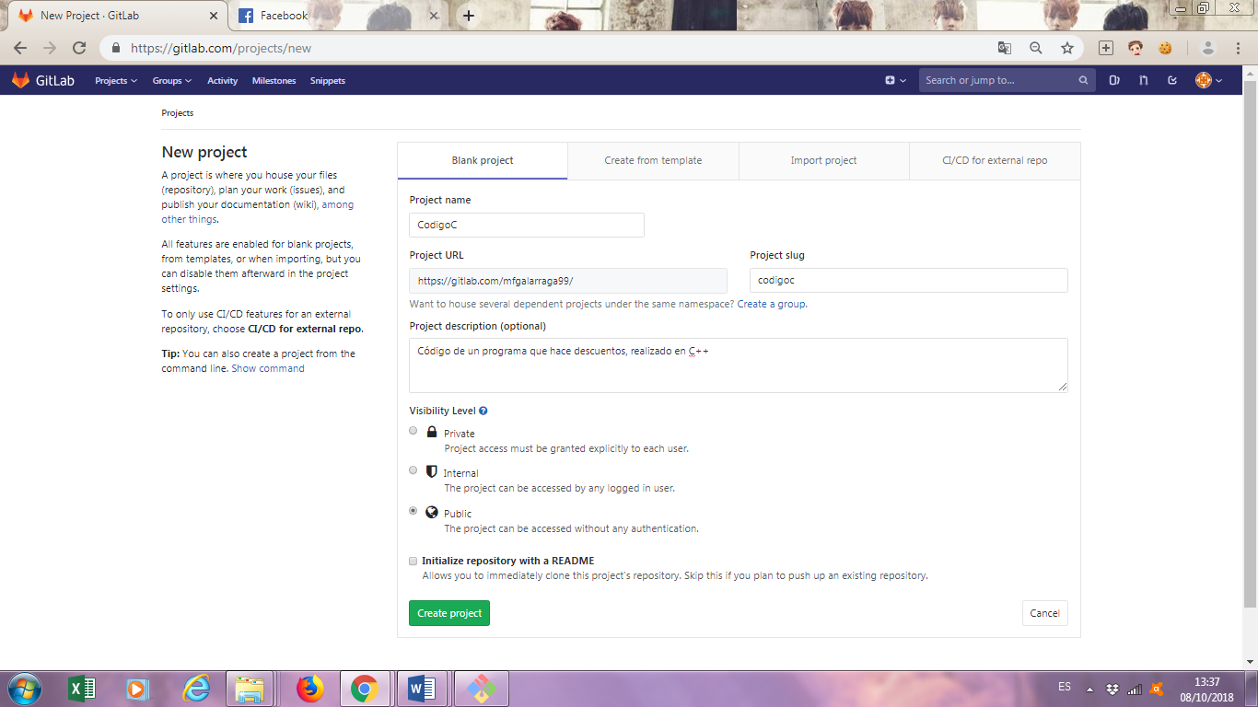

1. Select if we want our project to be private or public. Then click on Create Project.



1. Create a folder where the cpp file will be saved.

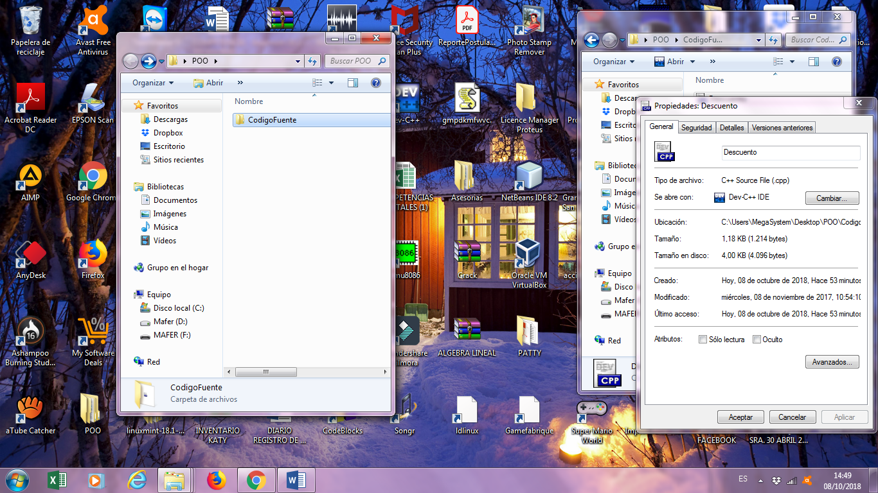

1. Open the Git Bash terminal.

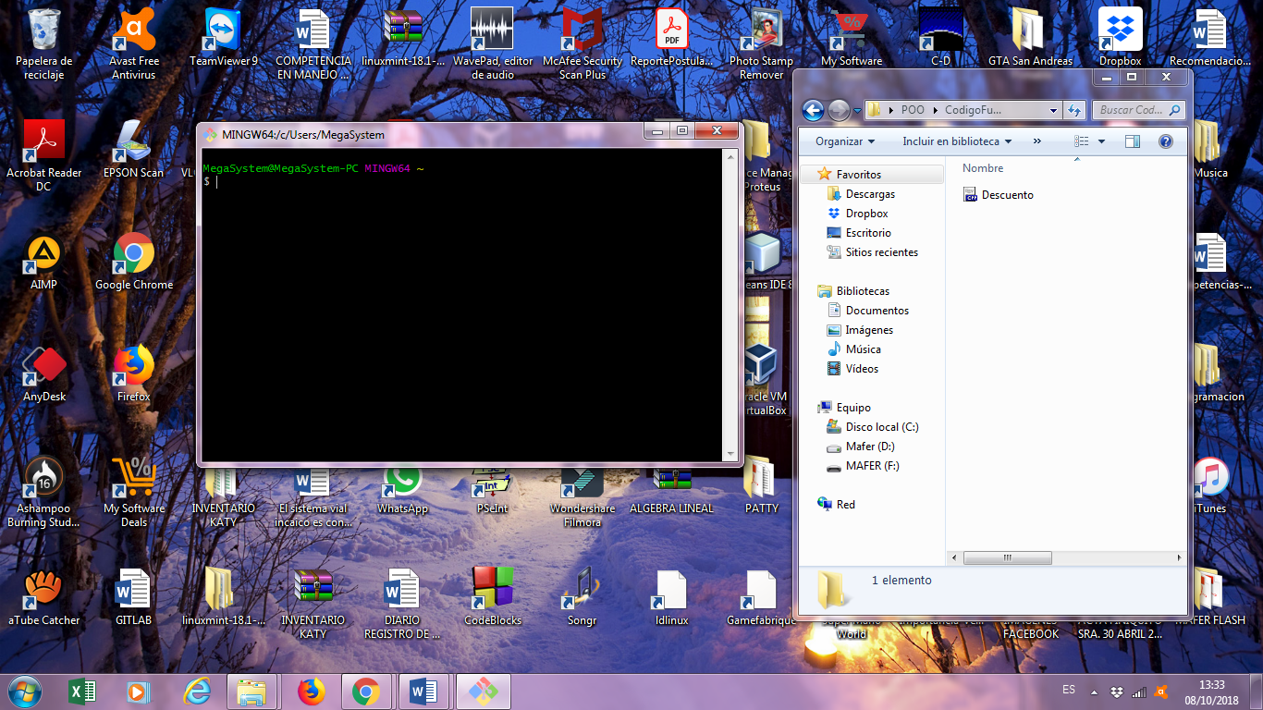

1. Access the folder where our cpp file is saved.

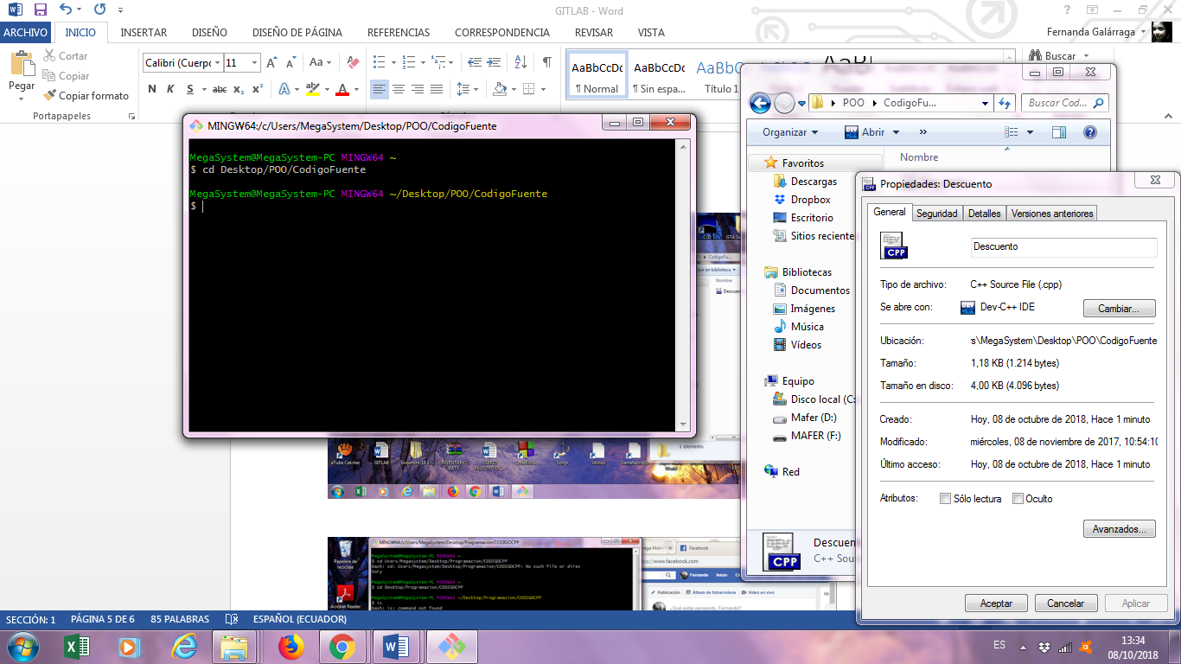

1. Place our user and mail using git config global user.name and user.email

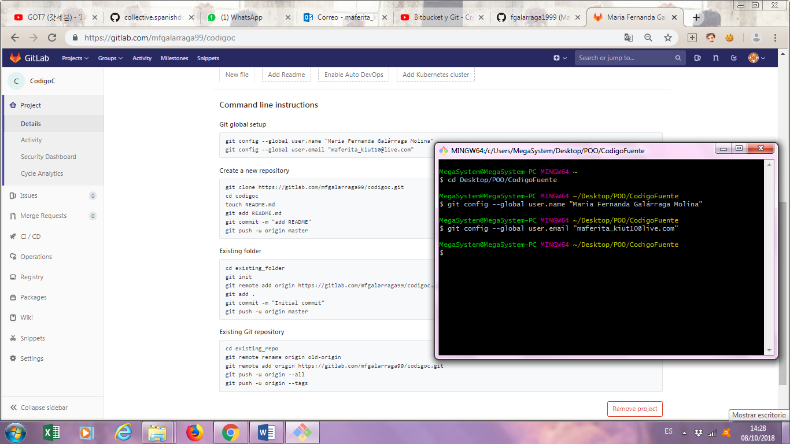

1. Initialize the repository with the git init command.

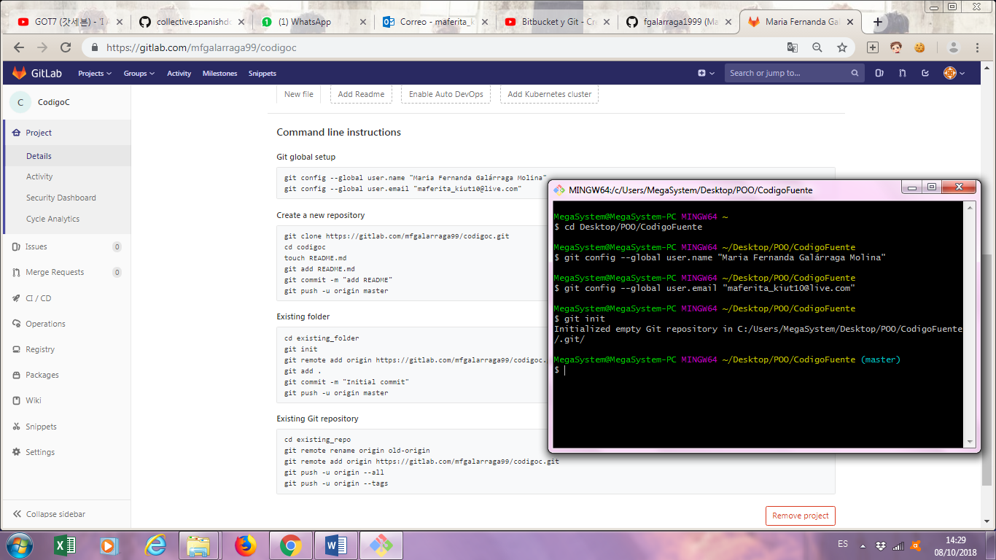

1. With the command git add . We specify what file we want to control.

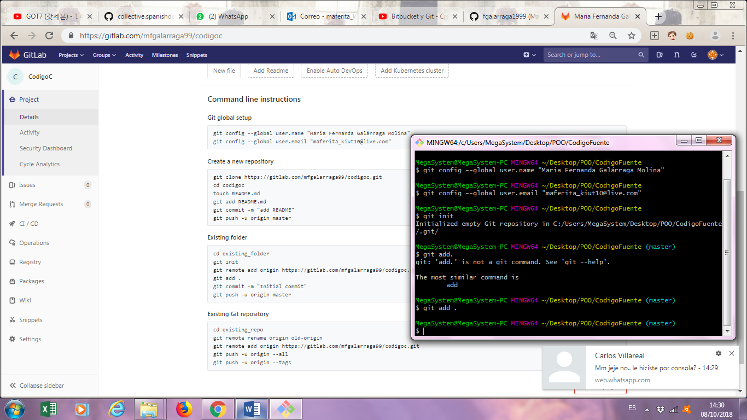

1. With the commit command, we save the changes we have made.

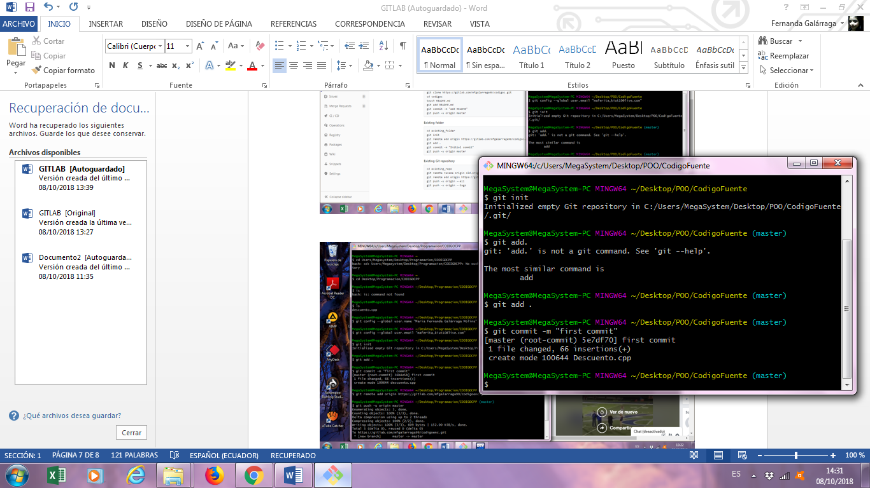

1. Type the command git remote to connect to the local repository.

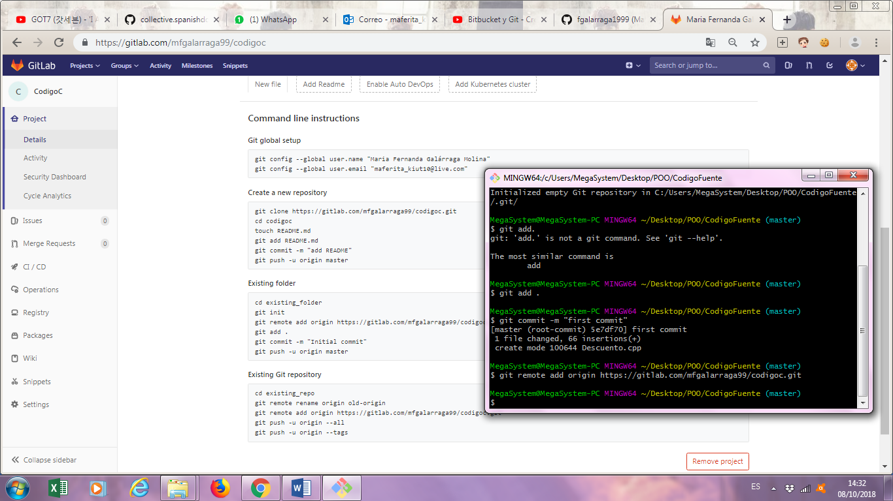

1. Use the git push command to send the cpp file to our remote repository.

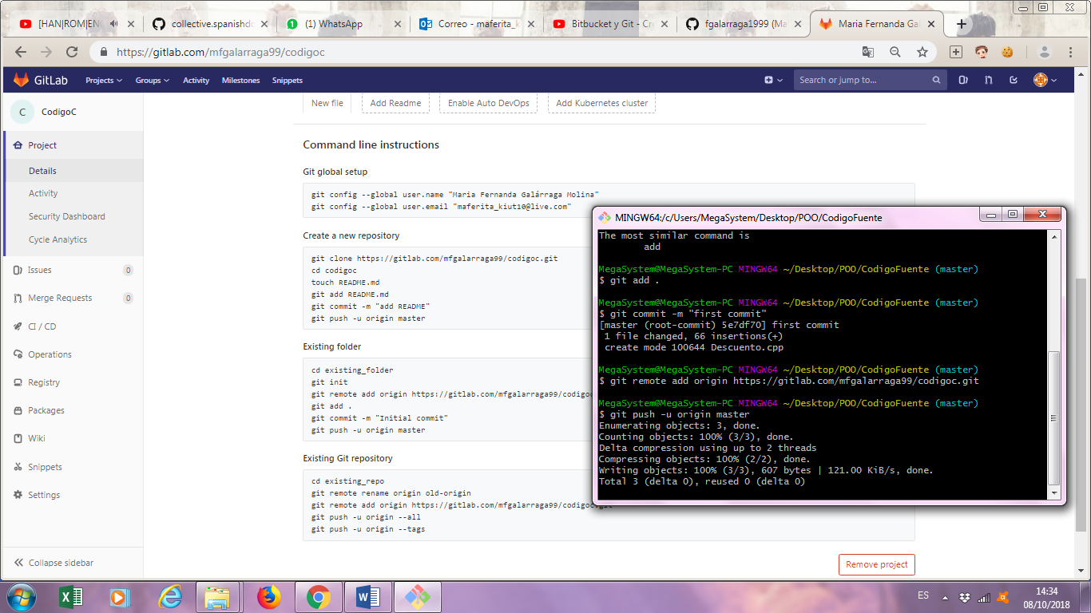

1. We update the GitLab page and you can view the cpp file that we upload.

